# Ameriya 50'' Upholstered Loveseat

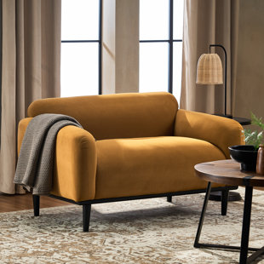

Price

$1,480

This loveseat's contemporary silhouette makes it an ideal addition to your den or living room. Crafted with a solid birch wood frame, it features a plush silhouette with round arms and a tight back filled with foam for an overstuffed look that invites you to lounge or read. It's balanced on four tapered dowel legs with a neutral finish and wrapped in polyester fabric for a tailored touch. Top perk: This loveseat supports up to 600 lbs. and resists stains, so it holds up in busy homes.